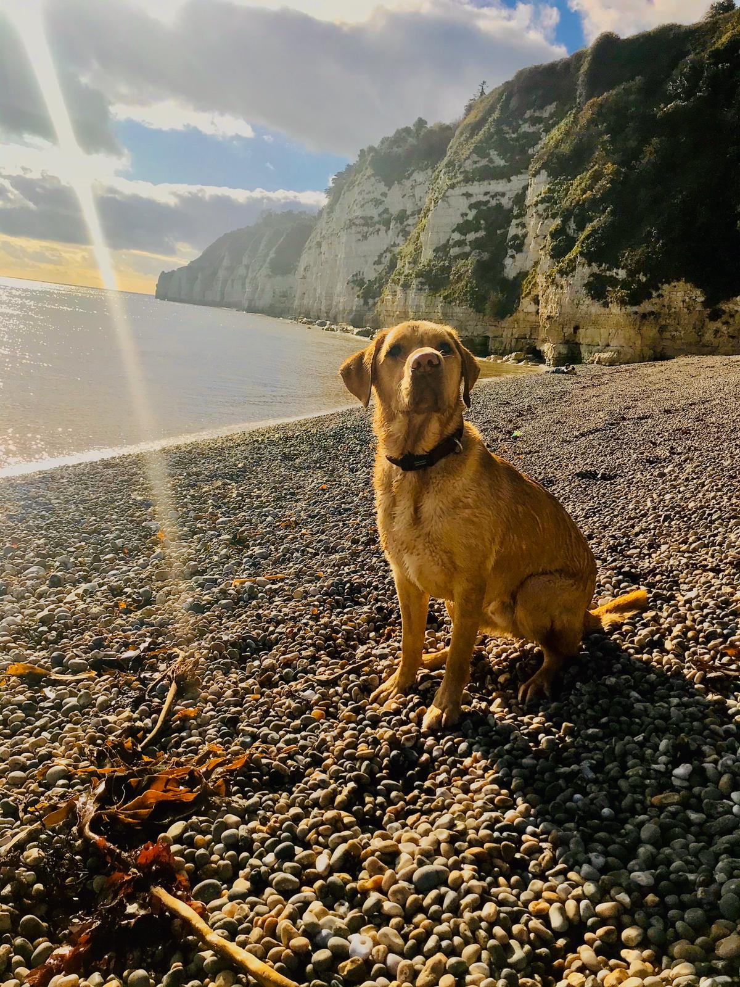
Dear Parents,
Here at All Saints’ Thurlestone, we are incredibly fortunate to have two wonderful school dogs, Henry and Chewie.
Henry is a Labrador and Chewie is a Labradoodle. Both are ideal breeds for a school pet due to their placid and patient nature (often used as therapy dogs).
A number of schools have introduced school dogs over the past few years and have seen great benefits from this. Children who do not have pets are able to experience looking after a pet in school, they can be used for comfort for children who may be having a difficult time and they have been used in many schools to help to develop confidence in reading - to just name a few benefits!
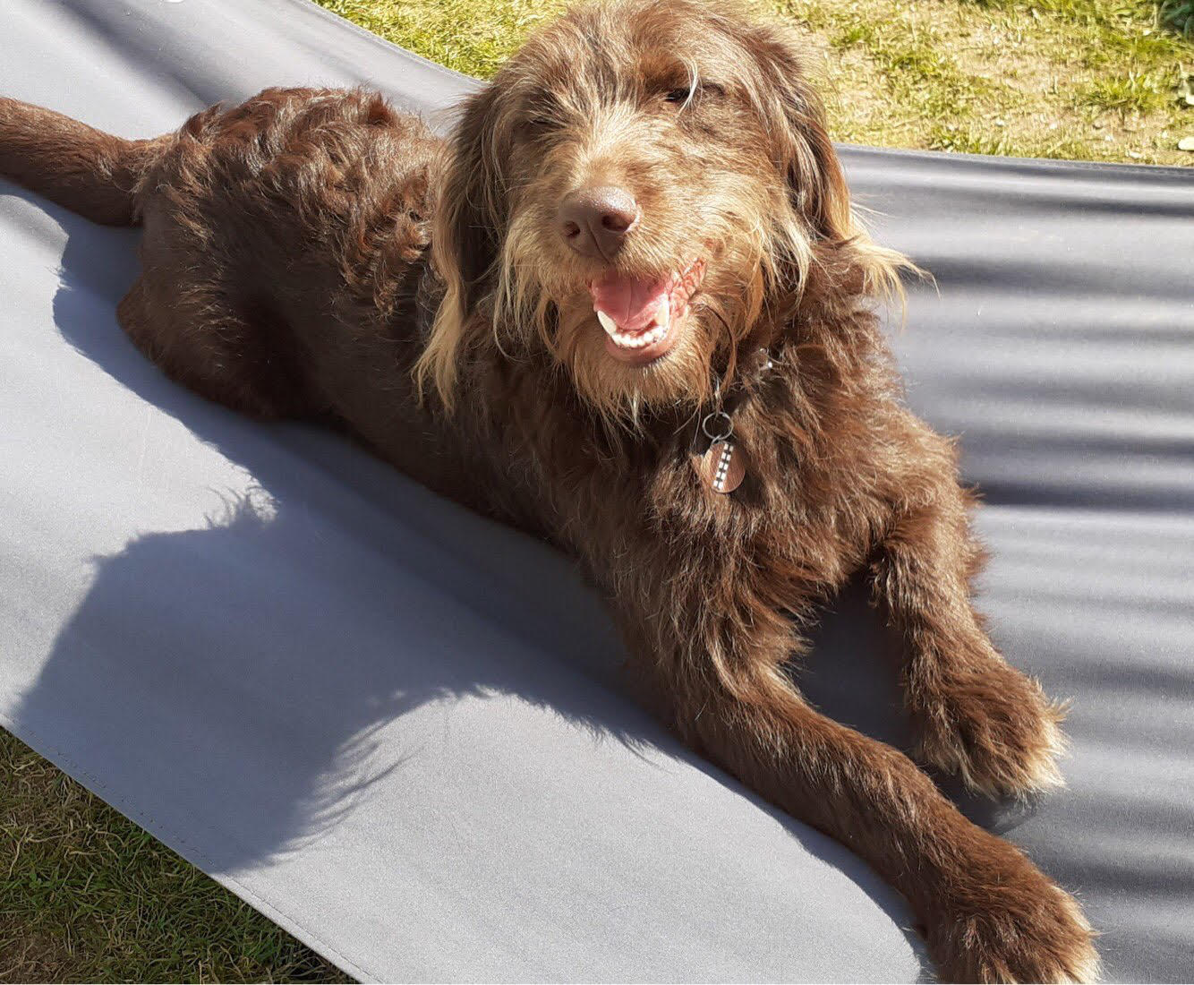
Henry and Chewie are not based in the school full time, and are gradually introduced to all of our new children, regardless of age, on an individual and small group basis, taking into account both the children and the dogs’ welfare at all times. No child will be unsupervised with either dog at any point, nor will any child be forced to spend time with them.
We are aware that there will be some concerns about having a school pet and we have carried out a full risk assessment to address some of these concerns.
- Allergies
Some children in the school may have allergies which are aggravated by pet hair. As a Labrador, Henry does shed hair, but Miss Kingston tries to keep this to a minimum with regular brushing. If there are children who are possibly affected by this, we will also restrict the areas of the school where he is able to be, reducing the risk of any type of irritation. Chewie is a Labradoodle and sheds very little/no hair. Mrs Callard also ensures Chewie is brushed regularly. If there are children who are possibly affected by this, we will also restrict the areas of the school where he is able to be, reducing the risk of any type of irritation
- Phobias
Both Henry and Chewie are big softies and their breeds are well known for their placid
temperament, we are aware that this is little reassurance to a child who may have a phobia of dogs.

If we are aware of phobias, we will do what we can to ensure that the child is not in contact with the dogs, again, restricting where in the school they are able to go. We absolutely do not want any child to be worried about coming into contact with Henry or Chewie as we recognise that this is detrimental to their welfare.

In addition to this restriction, please be assured that at no time will he be able to ‘wander’ around
the school, he will always be supervised by an adult. If you child has a phobia of dogs, please also
let us know if you would like to work with us to try to overcome the phobia, we will be guided by
you on this!

- The safety of the children
No child will be left unsupervised with the dogs at any time. Children will be taught how to touch and play with them, if they wish to do so.
- The welfare of the dogs
Henry and Chewie will not be in school every day and will not be left unsupervised at any time.
An adult will always be supervising the safety of both the children and the dog. If the dogs are
tired, then they are able to rest. Additionally, all children will be spoken to about not feeding
Henry or Chewie and about how to touch and play with them nicely.

If you have any further questions or concerns about your child and our school dogs, please do speak to your child’s class teacher or make an appointment through the office to meet with myself.
Please ensure that you complete the form below and return to the office as soon as possible so that we can ensure everyone’s safety and happiness alongside our four legged friends.
Yours sincerely
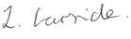
Miss L Garside
Executive Head of Academy

My child’s name __________________________________________________________________________
Class _____________________________________________ Year Group ___________________________
Please tick if appropriate

My child has an allergy to dogs
Please give details:

My child has a phobia/is scared of dogs
Please give further information about the phobia and if you would like us to work with your child to help overcome the phobia:

